**Structures and Interpretation of Computer Program**

**Exercise Chapter 2.3 Name:** Wan Huzaifah bin Wan Azhar

**Exercise 2.3.4 Huffman Encoding Tree**



(A D A B B C A)



(define sample-tree

(make-code-tree (make-leaf 'A 4)

(make-code-tree

(make-leaf 'B 2)

(make-code-tree (make-leaf 'D 1)

(make-leaf 'C 1)))))

(define (encode message tree)

(if (null? message)

'()

(append (encode-symbol (car message) tree)

(encode (cdr message) tree))))

(define (encode-symbol symbol tree)

(if (null? symbol)

'()

(cond

((leaf? tree) '())

((memq symbol (symbols (left-branch tree)))

(cons 0 (encode-symbol symbol (left-branch tree))))

((memq symbol (symbols (right-branch tree)))

(cons 1 (encode-symbol symbol (right-branch tree))))

(else (error "bad symbol -- Choose-Branch-Symbol" symbol)))))

(define sample-symbol '(A D A B B C A))

(display (encode sample-symbol sample-tree))

Output:

(0 1 1 0 0 1 0 1 0 1 1 1 0)



(define (generate-huffman-tree pairs)

(successive-merge (make-leaf-set pairs)))

(define (successive-merge leaves)

(if (null? (cdr leaves))

(car leaves)

(successive-merge (adjoin-set (make-code-tree (car leaves) (cadr leaves)) (cddr leaves)))))



* 84 bits is required to encode the lyric.
* Since there are 8 alphabet, 3 bits is the lowest fixed-length size for all alphabet.
* Total number of bits for the lyric given 3 bit of fixed-length size:
  + GET A JOB = (3 * 3) * 2 (repeated two times) = 18
  + SHA NA NA… = (9 * 3) * 2 = 54
  + WAH YIP… = 10 * 3 = 30
  + SHA BOOM = 2 * 3 = 6
  + Total = 108 bits to encode the lyric.
* As such, dynamic-length bits is definitely better.



N = 5 with each n = 2^n-1

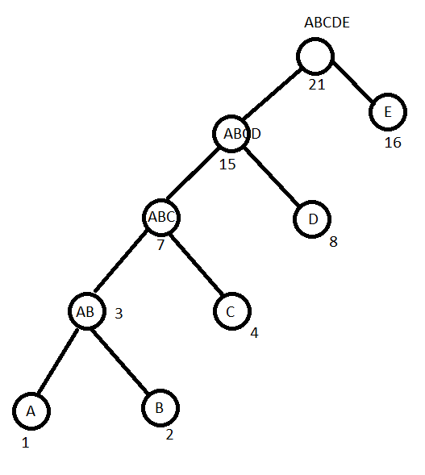

N = 10 with each weight n = 2^n -1

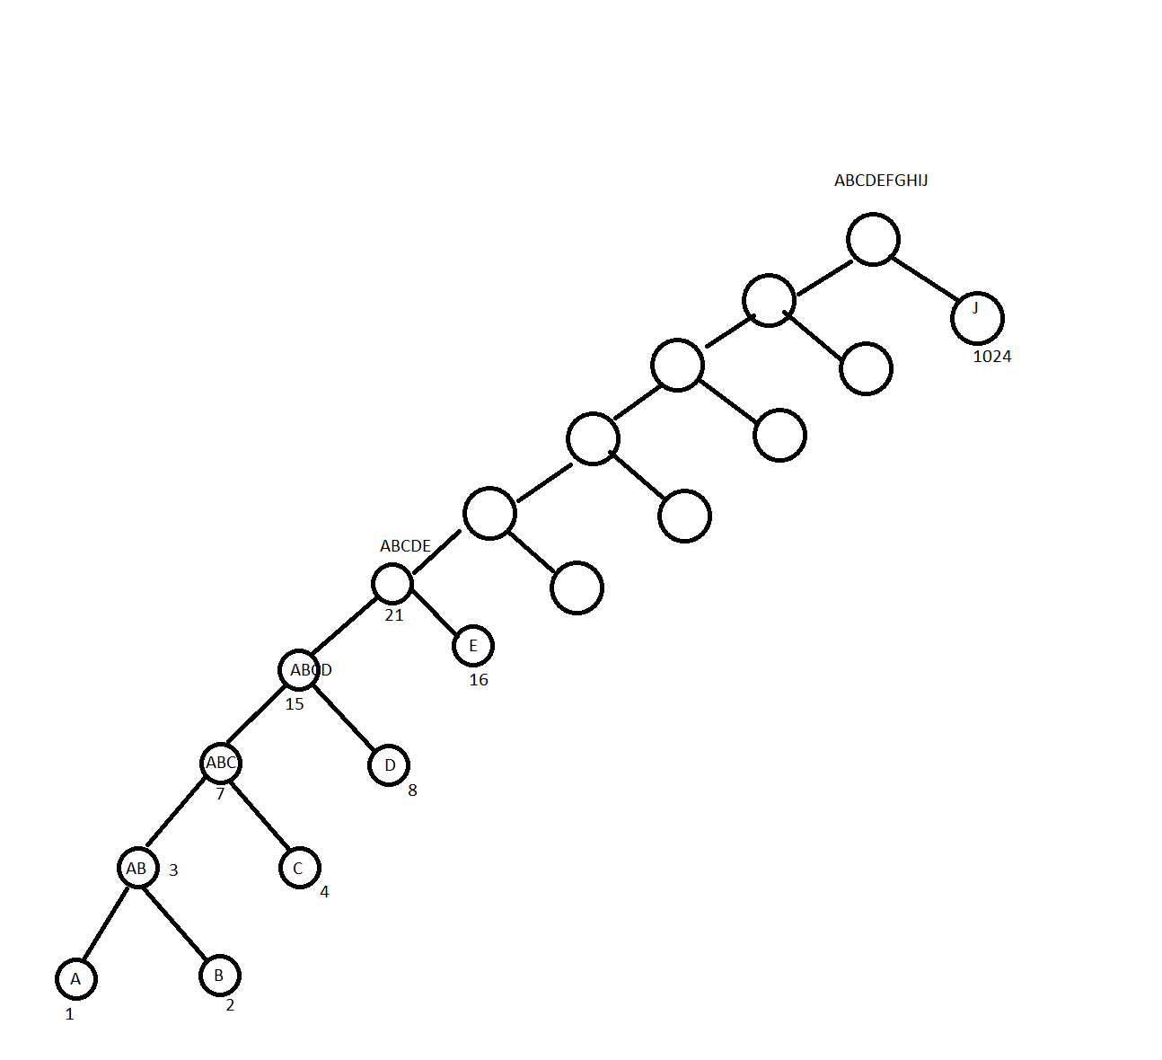

* For the most frequent symbol (most weight), only one bit are required, which is the first leaf of the right branch of the root node.
* For the least frequent symbol (least weight of 1), bits required to encode is n bits, which is deepest node on the left branch of the root node.